**ABSTRACT**

The pursuit of accurate and real-time facial detection in challenging conditions is at the core of our project's objectives. We meticulously design and develop an AI-based system, combining established facial detection models—Haar Cascade, MTCNN, and a proprietary model—in a comparative evaluation framework. This integration aims to identify the most accurate solution for challenging scenarios characterized by varying camera angles and poses.

MTCNN, standing out as the optimal detection model, becomes the cornerstone for the subsequent development of a robust facial recognition system. This choice is pivotal, considering the project's overarching goal: achieving precision and real-time responsiveness in the identification of faces from input video and camera feeds. The need for a solution is underscored by the ubiquity of dynamic real-world scenarios that necessitate adaptable and reliable facial detection systems.

Our project doesn't merely stop at selection; it delves into the implementation of features specifically tailored to handle varying conditions. This emphasis on adaptability ensures the reliability of our face detection system, making it adept at overcoming challenges posed by dynamic environments. The resulting AI-based system not only addresses the inherent complexities of facial detection but also sets the stage for practical applications across diverse domains, including security, surveillance, and human-computer interaction. In essence, our project contributes to the advancement of facial recognition technologies, offering a comprehensive and reliable solution for real-world scenarios.

**INTRODUCTION**

**1.1 Facial Recognition**

Facial recognition, a pivotal facet of computer vision, is a technology designed to identify and verify individuals based on their unique facial features. This cutting-edge application has garnered immense significance across various domains, ranging from security and surveillance to user authentication and human-computer interaction. The fundamental premise of facial recognition involves capturing and analyzing distinctive facial patterns, such as the arrangement of eyes, nose, and mouth, to establish a person's identity.

**1.2 Importance of Facial Recognition**

In the present era marked by the digitization of various aspects of daily life, the indispensability of accurate and reliable facial recognition systems is more pronounced than ever. The seamless integration of facial recognition technology yields profound benefits across multifaceted domains. Security protocols are fortified, ensuring heightened protection in sensitive environments. Access control mechanisms gain efficiency, reducing vulnerabilities associated with traditional methods. Moreover, personalized user experiences are elevated through innovative human-computer interaction methods, optimizing convenience and customization.

The significance of facial recognition is underscored by its transformative impact on security paradigms, offering a non-intrusive yet robust means of identity verification. The technology's adaptability extends beyond traditional realms, influencing user experiences in retail, finance, healthcare, and beyond. As society continues to embrace digital advancements, the demand for accurate and efficient facial recognition systems continues to surge.

**1.3 Objective**

Our objective is to design and develop an adaptive AI-based system, integrating established models like Haar Cascade and MTCNN, to reliably identify faces from video and camera feeds. We go a step further by implementing features tailored for varying conditions, contributing to the advancement of facial recognition in real-world scenarios.

**LITERATURE SURVEY**

1.**Rapid Object Detection using a Boosted Cascade of Simple Features**

Authors -Paul Viola ,[viola@merl.com](mailto:viola@merl.com) Mitsubishi Electric Research Labs, 201 Broadway, 8th FL Cambridge, MA 02139

Michael Jones, [mjones@crl.dec.com](mailto:mjones@crl.dec.com) Compaq CRL, One Cambridge Center, Cambridge, MA 02142

ACCEPTED CONFERENCE ON COMPUTER VISION AND PATTERN RECOGNITION 2001

The paper "Rapid Object Detection using a Boosted Cascade of Simple Features" by Paul Viola and Michael Jones is a seminal work in the field of computer vision and object detection. Published in 2001, this paper introduced the Viola-Jones object detection framework, which has since become a foundational algorithm for real-time object detection in images.

The key contribution of the paper lies in the development of an efficient and effective face detection system. The authors proposed a cascade of simple features that are computed in a rapid and hierarchical manner. These features are Haar-like features, which are rectangular filters that respond to variations in intensity within an image. The cascade structure allows for a quick rejection of non-face regions, enabling the algorithm to focus computational efforts on promising areas, leading to a significant speedup in the detection process.

One of the strengths of the Viola-Jones framework is its robustness and accuracy in detecting faces across different poses, lighting conditions, and backgrounds. The training process involves AdaBoost, a machine learning algorithm that combines weak classifiers into a strong classifier. This boosts the overall performance of the system and enhances its ability to discriminate between faces and non-faces.

The paper is well-organized and provides clear explanations of the algorithmic steps, making it accessible to a broad audience. The authors also conducted thorough experiments to demonstrate the effectiveness of their approach, showcasing impressive results in terms of both speed and accuracy.

Despite its groundbreaking contributions, it's important to note that the Viola-Jones framework is primarily designed for face detection and may not perform as well on more generic object detection tasks. Over the years, subsequent research has introduced more advanced deep learning-based methods that have surpassed the Viola-Jones algorithm in terms of overall performance on a wider range of objects and scenes.

**Drawbacks**

1. **Object Specificity:** Tailored for faces, it struggles with diverse objects and backgrounds.
2. **Haar-like Features:** Reliance on these limits capturing intricate patterns compared to modern methods.
3. **Sensitivity:** Sensitive to lighting and image quality, affecting performance.

2.**Joint Face Detection and Alignment using Multi-task Cascaded Convolutional Networks**

Authors-Kaipeng Zhang, Zhanpeng Zhang, Zhifeng Li, Senior Member, IEEE, and Yu Qiao, Senior Member, IEEE

The paper "Joint Face Detection and Alignment using Multi-task Cascaded Convolutional Networks" by Kaipeng Zhang et al. proposes a novel framework for joint face detection and alignment, achieving state-of-the-art performance on challenging benchmarks while maintaining real-time execution. This review analyzes the strengths and weaknesses of the proposed method, highlighting its contributions to the field.

Strengths of the Paper:

* Cascaded Architecture: The paper introduces a three-stage cascaded architecture that progressively refines face detection and alignment predictions. This coarse-to-fine approach significantly improves both accuracy and efficiency.
* Multi-task Learning: By jointly learning face detection and alignment tasks, MTCNN enables information sharing between them, further enhancing performance compared to learning each task separately.
* Real-time Performance: The proposed method is computationally efficient, running in real-time on standard hardware, making it suitable for practical applications requiring fast face processing.
* State-of-the-art Performance: MTCNN demonstrably outperforms existing methods on several challenging benchmarks like FDDB, WIDER FACE, and AFLW, establishing its effectiveness.

Overall Significance and Future Directions:

MTCNN presents a significant contribution to the field of face detection and alignment, achieving state-of-the-art performance while maintaining computational efficiency. This makes it a valuable tool for real-world applications where fast and accurate face processing is crucial.

Future work could explore deeper network architectures to potentially further improve performance. Additionally, incorporating other related tasks into the multi-task learning framework could expand the capabilities of MTCNN and increase its applicability to diverse scenarios.

Accessibility and Conclusion:

To reach a broader audience, the paper could benefit from a more concise introduction to the problem of face detection and alignment, along with existing methods. This would provide context for readers new to the field.

In conclusion, Kaipeng Zhang et al. present a novel and effective approach to joint face detection and alignment through MTCNN. This framework represents a significant advancement in the field and has the potential to be widely adopted in various real-world applications requiring accurate and efficient face processing.

**Drawbacks**

* Unclear network architecture.
* Missing ablation study.
* Lacks real-time method comparison.

**3.VERY DEEP CONVOLUTIONAL NETWORKS FOR LARGE-SCALE IMAGE RECOGNITION**

Authors-Karen Simonyan & Andrew Zisserman , Visual Geometry Group, Department of Engineering Science, University of Oxford

Published as a conference paper at ICLR 2015

The paper "Very Deep Convolutional Networks for Large-Scale Image Recognition" (VGGNet) proposes a series of convolutional neural network (CNN) architectures with increasing depth for image recognition. VGGNet's key contribution is demonstrating the effectiveness of significantly deeper networks than previously explored, achieving state-of-the-art performance on the ImageNet classification task.

Strengths:

* Deep Network Architecture: VGGNet successfully employs much deeper networks than previously explored, with up to 19 convolutional layers, demonstrating the potential of significantly increased depth for image recognition.
* Image Augmentation: VGGNet introduces a novel image augmentation technique called "image jittering," which involves randomly modifying the scale, aspect ratio, and position of images during training, leading to improved robustness andgeneralizability.
* Evaluation Techniques: The paper presents various evaluation techniques, including dense predictions, multi-crop, and multi-crop & dense predictions, providing a comprehensive analysis of the models' performance.
* State-of-the-Art Performance: VGGNet achieves state-of-the-art performance on the ImageNet classification task, surpassing previous models and demonstrating the effectiveness of its proposed architecture.

Overall, VGGNet is a significant contribution to the field of image recognition, demonstrating the effectiveness of deep convolutional networks and introducing novel techniques. While it has some limitations in computational cost and analysis depth, its impact on the field is undeniable.

VGGNet is a landmark paper in the field of deep learning for image recognition. Its key contribution of demonstrating the effectiveness of significantly deeper networks has paved the way for further research and development in this area. While it has some limitations, VGGNet's impact on the field is undeniable, and it remains a valuable reference point for researchers and practitioners alike.

**Drawbacks**

* High computational cost.
* Lacks detailed architecture analysis.
* Missing comparison with newer models.

**PRELIMINARY IDEAS**

3.1 **Haar- Cascade**

The Haar Cascade algorithm is a machine learning object detection method used to identify objects or faces in images or video. It was introduced in the paper "Rapid Object Detection using a Boosted Cascade of Simple Features" by Viola and Jones. Here's an overview of how the Haar Cascade algorithm works:

1. Haar-like Features:
   * Haar-like features are rectangular filters that respond to variations in intensity within an image. These features can capture simple patterns like edges and textures.
2. Integral Image:
   * To compute Haar-like features efficiently, an integral image is used. The integral image representation allows for the rapid calculation of the sum of pixel intensities within any rectangular region of an image.

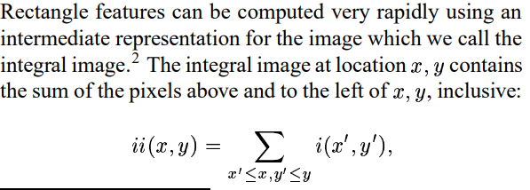

1. Adaptive Boosting (AdaBoost):
   * The algorithm employs AdaBoost to select a small set of critical Haar-like features from a large pool. These features collectively form a strong classifier capable of distinguishing between positive and negative examples (e.g., faces and non-faces).
2. Cascade Classifier:
   * The Haar Cascade operates as a cascade of classifiers arranged in stages. Each stage consists of a subset of the selected Haar-like features.
   * During the detection process, the cascade structure allows for a quick rejection of non-object regions. If a region passes the first stage, it proceeds to subsequent stages for further scrutiny.
3. Training:
   * The training process involves providing positive and negative examples to the algorithm. Positive examples contain the object of interest (e.g., faces), and negative examples are non-object regions.
   * The algorithm iteratively trains weak classifiers on different subsets of the training data, assigning higher weights to misclassified examples. This process focuses on improving the algorithm's performance on challenging instances.
4. Real-Time Object Detection:
   * Once the cascade is trained, it can be applied to detect objects in real-time. The hierarchical nature of the cascade ensures that most image regions are quickly rejected, allowing the algorithm to focus computational efforts on promising areas.
5. Applications:
   * Haar Cascade has been widely used for face detection but can be adapted for other object detection tasks. Its efficiency and speed make it suitable for real-time applications, and it has been an essential component in various computer vision systems.

3.2 **MTCNN**

MTCNN, which stands for Multi-task Cascaded Convolutional Networks, is a widely used face detection algorithm developed for detecting and aligning faces in images. It was introduced by Kaipeng Zhang, Zhanpeng Zhang, Zhifeng Li, and Yu Qiao. MTCNN is known for its capability to handle face detection, facial landmark localization, and face alignment in a single unified framework. Here are the key components and steps involved in the MTCNN algorithm:

1. Three Stages:
   * MTCNN operates in three stages, each designed to address a specific task: face detection, facial landmark localization, and face alignment.
2. Stage 1 - Proposal Network (P-Net):
   * The first stage, P-Net, proposes candidate face regions by using a fully convolutional network. It applies a set of predefined anchor boxes at different positions and scales to predict whether there is a face or not in each region.
3. Stage 2 - Refinement Network (R-Net):
   * The second stage, R-Net, refines the face proposals generated by P-Net. It rejects non-face regions and refines the bounding boxes by applying more sophisticated convolutional neural networks.
4. Stage 3 - Output Network (O-Net):
   * The third stage, O-Net, further refines and narrows down the candidate face regions. It performs facial landmark localization, predicting the positions of key facial landmarks, such as eyes, nose, and mouth.
5. Non-Maximum Suppression (NMS):

After each stage, a non-maximum suppression algorithm is applied to filter out redundant and overlapping bounding boxes, keeping only the most confident face detections.

1. Face Alignment:
   * MTCNN not only detects faces but also provides facial landmark localization and face alignment. This makes it useful for tasks such as facial feature analysis.
2. Applications:
   * MTCNN is widely used in various applications, including face recognition, emotion analysis, and human-computer interaction. Its ability to handle multiple tasks in a single pass makes it efficient for real-time face detection scenarios.
3. Performance:
   * MTCNN has shown good performance in terms of accuracy and speed compared to earlier methods. However, it may not be as accurate as more recent deep learning-based object detection models like Single Shot MultiBox Detector (SSD) or You Only Look Once (YOLO) for broader object detection tasks.

MTCNN has been influential in the field of face detection, providing an efficient and effective solution for detecting and aligning faces in images with real-time constraints.

**3.3 Face Tracker**

Face detection algorithm:

1. Capture images using webcam including images without faces.

2. Draw bounding boxes around faces in captured images and store these coordinates and a label value indicating whether image has a face or not in a json file.

3. Split these images into three portions - training, validation and testing in the ratio of 80%, 10% and 10%.

4. Use a python image augmentation library to read each image from above three sets and create a set of sixty new images from original image using transformations such as horizontal, vertical flip, brightness, etc and also generate corresponding bounding boxes saved to json files.

5. Import the VGG face detection model to use the base model of our model.

6. Our model builds on the VGG model by adding layers corresponding to face detection and boundary box detection combining classification and regression tasks.

7. Create loss functions for classification and regression loss.

8. Build the model.

9. Train the model for a set of epochs and monitor the training and validation classification and regression losses.

10. Save the model.

11. Load the model and use it to detect faces captured in webcam.

**3.4 Convolutional Neural Networks (CNNs)**

* For applications in the vision domain, Convolutional Neural Networks or CNNs are more suitable than feed forward Neural Networks.
* CNNs primarily takes an image and uses convolution operations to generate a hierarchy of abstract representations of the image over which tasks such as image classification, object detection, segmentation, etc. can be performed.
* A convolution filter is a mxn matrix of values which slides over the input image and an output value calculated as follows –

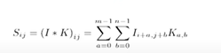

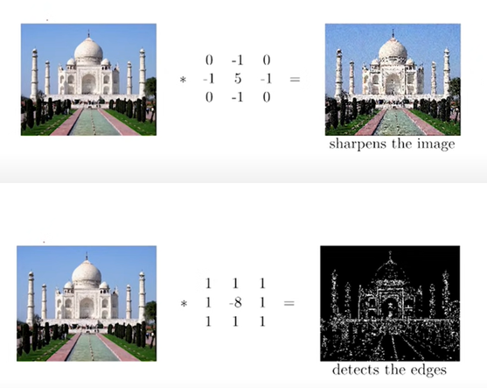 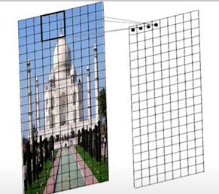

Kernels in CNNs

* In CNNs instead of using pre-determined kernels to detect edges etc, the kernel weights can be learnt as part of the model training process to gain more insights into the images being studied.
* Multiple kernels can be used in a CNN model whose weights can be learnt to extract different features of the input images during training.
* In addition to multiple kernels, we can use multiple layers of kernels to progressively detect features of the input images at different layers of abstraction.
* The kernel weights and the classifier weights are learnt during the training phase of the model.

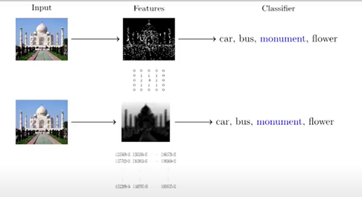

CNN model

* The figure below shows a CNN model for an image classification problem.
* The input consists of a 32x32 image.
* The next layer is a convolutional layer consisting of 6 kernels.
* This is followed by a Pooling layer to reduce the size of the data, followed by Convolutional layer 2 and another pooling layer.
* Finally the last layer is flattened and passed through two Dense (fully connected) layers to perform the classification task.
* Finally there is the Output layer consisting of the Softmax function to classify the images.

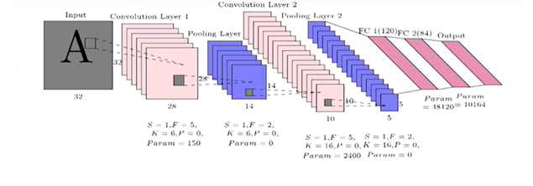

**3.5 VGG16**

VGG16, short for Visual Geometry Group 16, is a convolutional neural network (CNN) architecture that was introduced by the Visual Geometry Group at the University of Oxford. It is one of the variants of the VGG architecture and is specifically designed for image classification tasks. VGG16 is known for its simplicity and uniform architecture, making it easy to understand and implement.

Here are key characteristics of the VGG16 architecture:

1. **Architecture:**
   * VGG16 consists of 16 layers, including 13 convolutional layers and 3 fully connected layers.
   * The convolutional layers use small 3x3 filters with a stride of 1 and 'same' padding, maintaining spatial resolution.
   * The pooling layers utilize 2x2 max-pooling with a stride of 2, reducing spatial dimensions.
2. **Filter Size and Depth:**
   * All convolutional layers uses 3x3 filters, and the number of filters increases with the depth of the network.
   * The depth of the filters in convolutional layers starts with 64 filters and doubles after each max-pooling layer.
3. **Activation Function:**
   * Rectified Linear Unit (ReLU) activation functions are used throughout the network, except for the output layer.
4. **Fully Connected Layers:**
   * The three fully connected layers have 4096 neurons each, leading to a high number of parameters.
   * The last fully connected layer has 1000 neurons, corresponding to the 1000 classes in the ImageNet dataset, for which VGG16 was originally designed.
5. **Output Layer:**
   * The output layer uses the softmax activation function to produce class probabilities.
6. **Pre-trained Models:**
   * VGG16 is often used as a pre-trained model for various computer vision tasks, serving as a feature extractor or fine-tuned for specific applications.
   * Pre-trained weights on large datasets, such as ImageNet, are available and widely used for transfer learning.
7. **Applications:**
   * VGG16 has been successfully applied to image classification, object detection, and other computer vision tasks.
   * While it has been influential, its large number of parameters can be computationally expensive for real-time applications on resource-constrained devices.

**OUR WORK**

**FLOWCHART OF THE PROCESS**

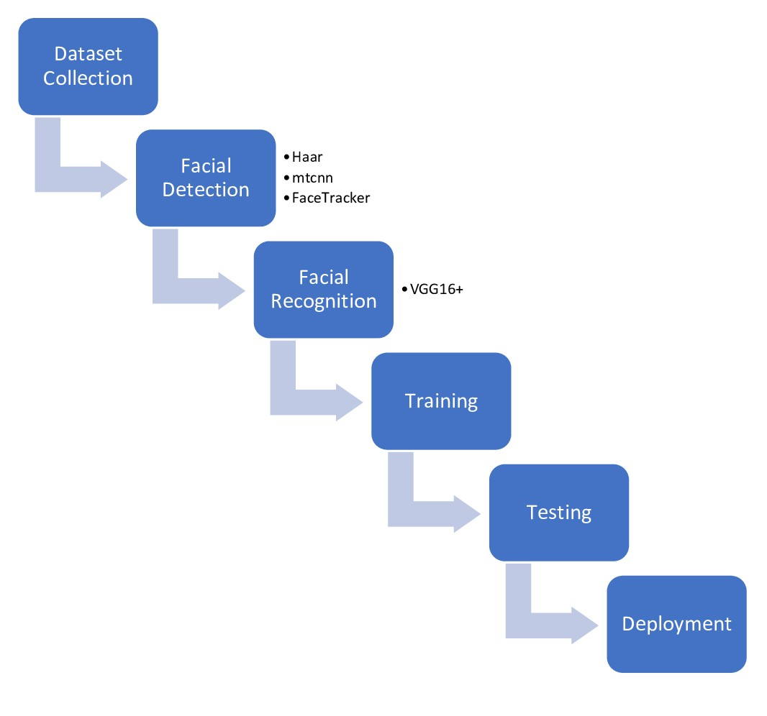

**Implementation of Haar-Cascade :**

1. **Installation of OpenCV:**
   * We ensured that OpenCV, a widely-used computer vision library, was installed in the project environment to leverage its tools for Haar Cascade-based face detection.
2. **Acquisition of Haar Cascade Classifier XML File:**
   * A trained Haar Cascade classifier XML file, specifically designed for face detection, was obtained. This file encapsulates features required for recognizing faces.
3. **Initialization of the Cascade Classifier:**
   * The trained Haar Cascade classifier was loaded using OpenCV. This classifier acts as a machine learning model capable of identifying patterns resembling faces.
4. **Reading and Preprocessing of the Image:**
   * Images where face detection was desired were read. To align with the Haar Cascade classifier, the images were converted to grayscale, as this method typically performs well with such images.
5. **Execution of Face Detection:**
   * We utilized OpenCV's **detectMultiScale** method, passing the grayscale image and specific parameters. This method systematically searched for faces in the image at various scales and returned the locations of detected faces.
6. **Drawing Rectangles Around Detected Faces:**
   * A systematic iteration through the coordinates of the detected faces was performed, drawing rectangles around them on the original image. This step visually highlighted the regions identified as faces.
7. **Displaying or Saving Results:**
   * Optionally, we chose to either display the image with the drawn rectangles around detected faces for visual inspection or save the processed image for further analysis or integration into the project.
8. **Integration with the Project:**
   * The face detection code was seamlessly integrated into the project's structure, aligning with the overall objectives. This integration may have involved incorporating the code into a larger system or workflow as needed.

**Implementation of MTCNN:**

1. **Integration of MTCNN:**
   * The team opted to implement MTCNN, a cutting-edge face detection algorithm recognized for simultaneously handling face detection, facial landmark localization, and face alignment within a unified framework.
2. **Acquisition of MTCNN Model:**
   * The team trained a MTCNN model, which encompasses the neural networks necessary for each of its three tasks - face detection, facial landmark localization, and face alignment.
3. **Integration with OpenCV:**
   * OpenCV was employed in conjunction with the MTCNN model. OpenCV served as a crucial tool for image processing and handling, while MTCNN contributed advanced face detection capabilities.
4. **Reading and Preprocessing of the Image:**
   * Input images designated for face detection were read and pre-processed. MTCNN, similar to many deep learning-based models, often performs optimally with images in standard formats and colour spaces.
5. **Execution of Face Detection:**
   * The MTCNN model was applied to the pre-processed images, leveraging its multi-stage architecture to detect faces, localize facial landmarks, and align detected faces.
6. **Handling of Multiple Tasks:**
   * MTCNN's unique capability to handle multiple tasks in a unified manner allowed the team to not only detect faces but also obtain detailed information, such as the locations of facial features and the alignment of faces.
7. **Displaying and Saving Results:**
   * Based on project requirements, the team both displayed the processed images with annotated face detections and landmarks for visual inspection and saved the results. This dual approach facilitated both immediate assessment and future analysis.
8. **Integration with the Project:**
   * The MTCNN implementation seamlessly integrated into the project's structure, aligning with the team's goals. This integration involved incorporating the code into the existing system or workflow, considering the project's specific needs and objectives.

**Implementation of Facetracker Algorithm**

1. **Image Capture using Webcam:**
   * Utilized a webcam to capture images, ensuring a diverse dataset that includes images both with and without faces.
2. **Bounding Box Annotation:**
   * Implemented face annotation by drawing bounding boxes around detected faces in captured images. Stored the coordinates of these bounding boxes along with a label indicating whether the image contains a face or not in a JSON file.
3. **Dataset Splitting:**
   * Split the annotated images into three sets – training, validation, and testing – maintaining a ratio of 80%, 10%, and 10%, respectively.
4. **Image Augmentation:**
   * Applied image augmentation using a Python library to generate sixty new images from each original image in the three sets. Employed transformations such as horizontal and vertical flips, changes in brightness, and other augmentations. Corresponding bounding boxes were generated and saved in JSON files.
5. **Importing VGG Face Detection Model:**
   * Imported the VGG face detection model as the base model for the project. The VGG model is a widely-used convolutional neural network (CNN) architecture known for its effectiveness in image classification tasks.
6. **Model Architecture Enhancement:**
   * Extended the VGG model by adding layers specifically designed for face detection and bounding box detection. Combined classification and regression tasks within the model architecture.
7. **Loss Function Definition:**
   * Created custom loss functions to handle both classification and regression losses, accommodating the dual tasks within the model.
8. **Model Building:**
   * Constructed the final model, which integrates the VGG base with additional layers for face detection and bounding box prediction.
9. **Training the Model:**
   * Trained the model for a specified number of epochs, continuously monitoring training and validation losses for both classification and regression tasks.
10. **Model Saving:**
    * Saved the trained model, preserving the learned parameters and architecture for future use.
11. **Model Deployment and Inference:**
    * Loaded the saved model to use it for face detection on new data. The deployed model was capable of detecting faces in real-time webcam captures, showcasing the effectiveness of the trained algorithm.

**Implementation of Face recognition using VGG16+**

1. From the three algorithms tried for face detection and bounding box regression, MTCNN model selected due to highest accuracy.

2. For facial recognition we use transfer learning with VGGFace as the base model. To this we add few fully dense layers and the final layer has same number of neurons as number of individual faces to be classified with softmax activation. For loss function categorical cross entropy loss function is used.

3. For input to our model we organise pictures of individuals into separate folders. The images are read and the MTCNN facial detection model is used to detect faces in these images and use the boundary box coordinates output by MTCNN to extract the face from the image, resize it to 224x224 pixels and store it in a training images folder.

4. Next our model reads these images from the training folder and uses the Tensorflow Image Data Generator package to pre-process the input images by applying various geometric transformations to increase the input data size.

5. The model is then trained over several epochs using the generated input data and loss functions described above .

6. The model is then saved in hard disk along with a dictionary structure of number of classes and class descriptions comprising of names of individuals whose pictures have been trained.

7. The model and dictionary structure is subsequently loaded.

Images stored in a test directory are then read and faces extracted using MTCNN and faces extracted resized, pre-processed and input to our facial recognition model to classify the face. The name of the person with highest predicted probability of association with input image is then output.

**DATASET, RESULTS &** **DISCUSSION**

**5.1 DATASET DETAILS**

We have a highly imbalanced (high non-churners) dataset of Human faces, non faces and animal faces which consists of 100 pictures. The dataset is created by handpicking all possible different pictures which can prove to be challenging for our facial recognition. These images were trained by our model and tested to find the output.

The dataset is shown as below:

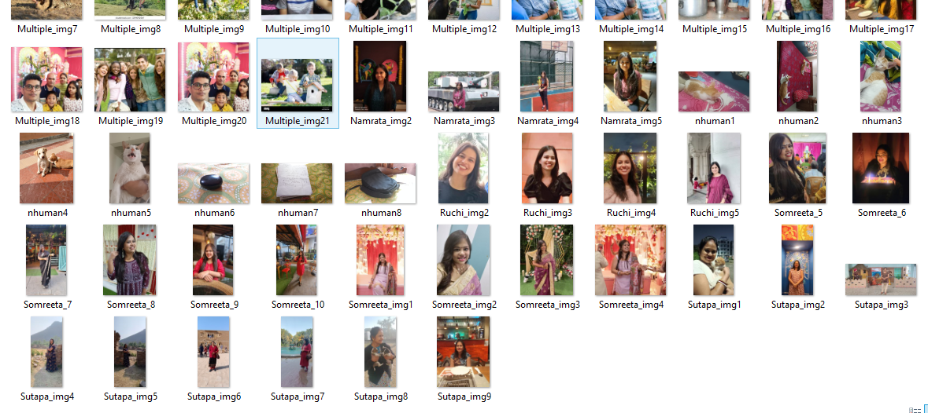

**5.2 DISCUSSION**

**For Haar-Cascade:**

The output obtained from the implementation of Haar-Cascade is shown below

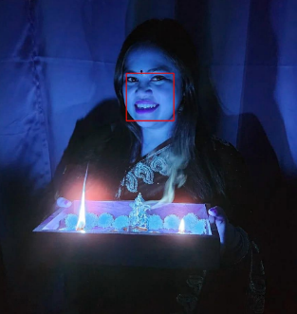 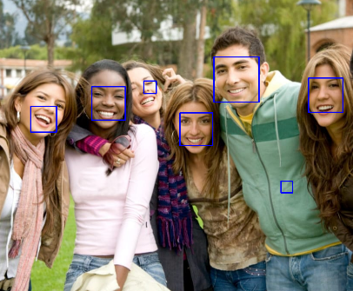 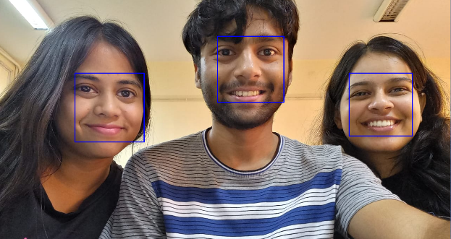

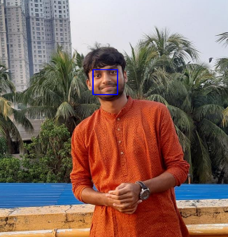 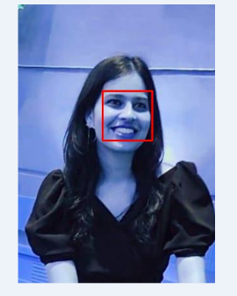 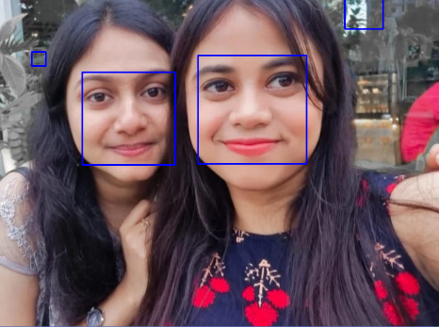

**For MTCNN:**

The output obtained from the implementation of MTCNN is shown below

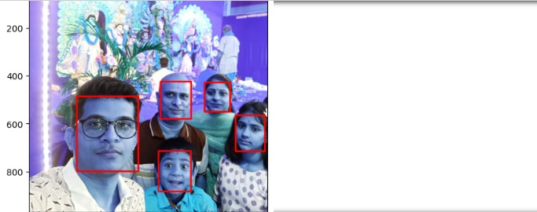

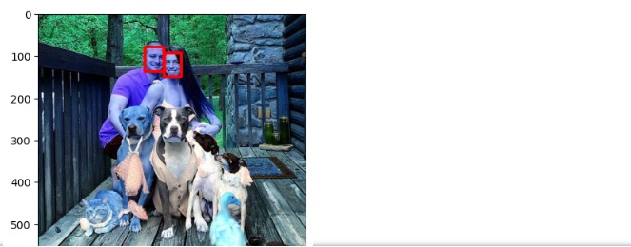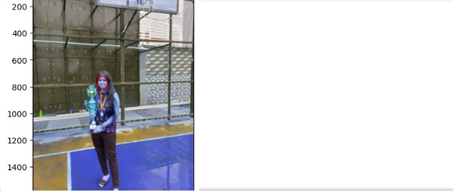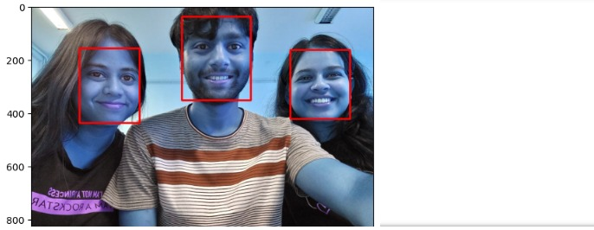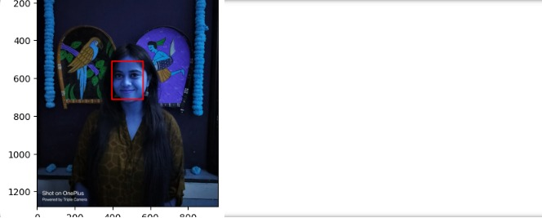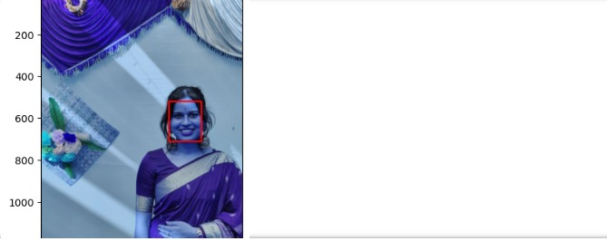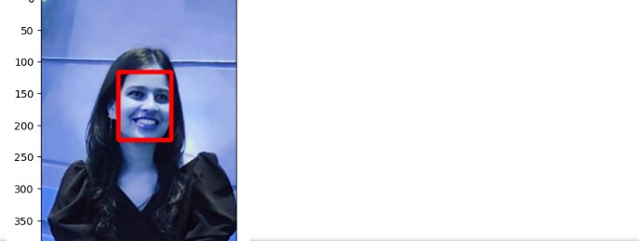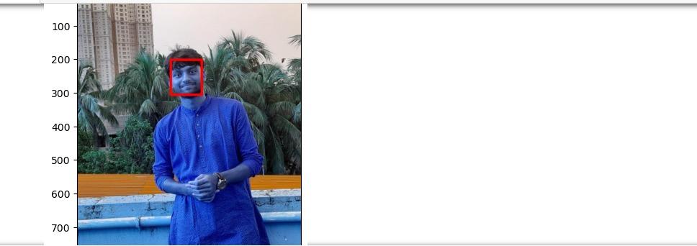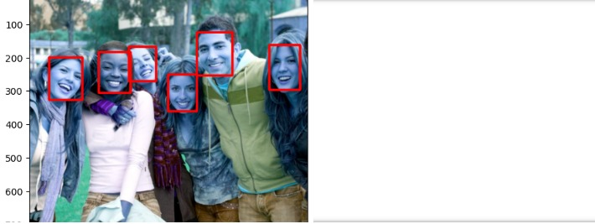

**For Face Tracker:**

The output obtained from the implementation of Face Tracker is shown below

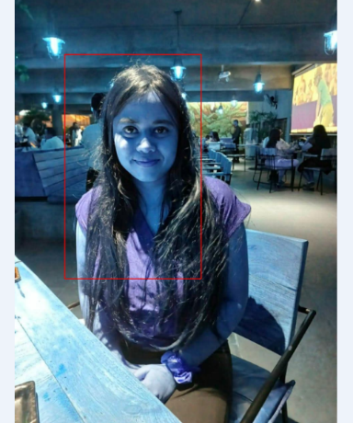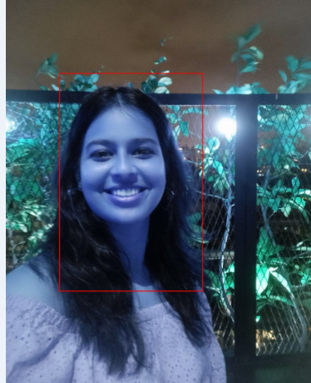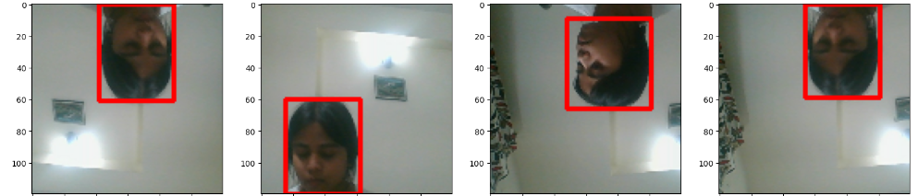

**For VGG16+:**

The output obtained from the implementation of VGG16+ is shown below

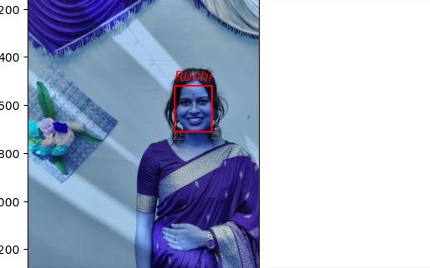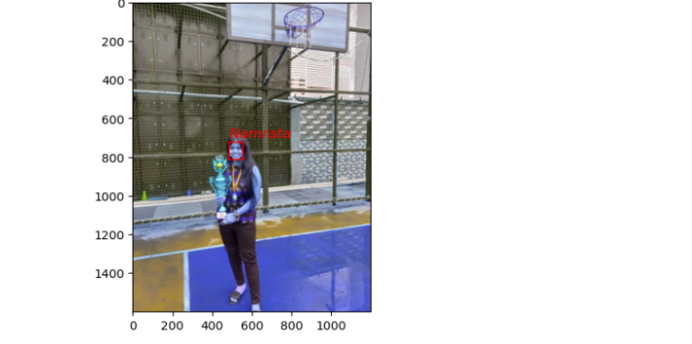

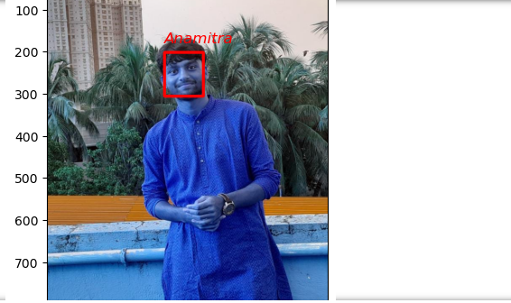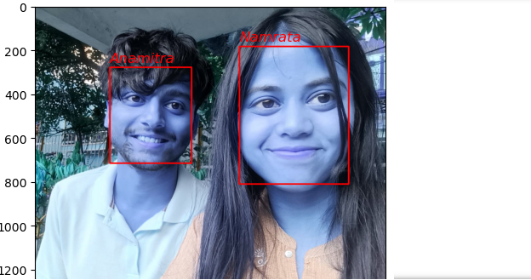

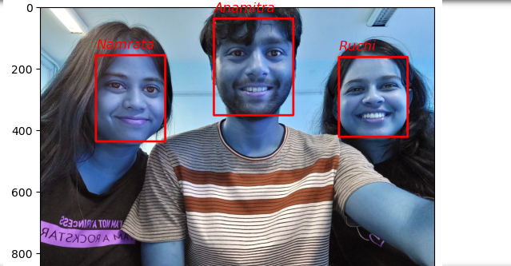

5.3 **Obtained Analysis Graph:-**

In the bar graph shown below, the first pair of bar graphs shows the accuracy comparison between individual algorithms, The second graph pair shows the precision ratio comparison which is plotted by multiplying it by 100, The third graph pair shows the sensitivity comparison which is plotted by multiplying it by 100. The forth pair shows execution Time (of 1 record) for Haar-Cascade, MTCNN, Face Tracker, VGG16+ which are plotted in terms of seconds.

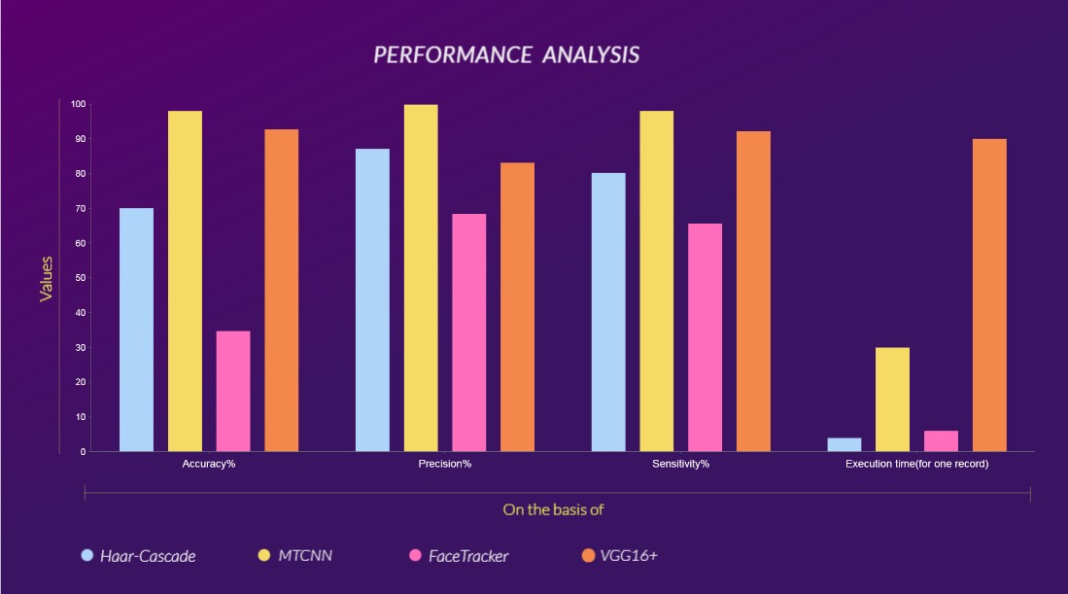

This is the graph that we obtained which shows all the comparative parameters like accuracy, precision, sensitivity, execution time (for 1 record) for Haar-Cascade, MTCNN, Face Tracker, VGG16+.

**Confusion matrix Used:**

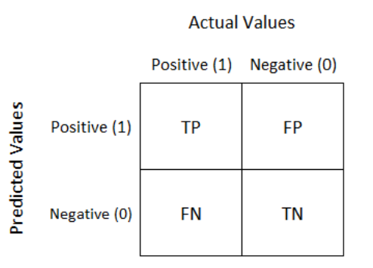

Parameters are calculated as per the below formulas:

Accuracy = (TP+TN) / (TP+FP+FN+TN)

Precision ratio = TP / (TP+FP)

Sensitivity = TP / (TP+FN)

**5.4 Table Of Results:**

|  |  |  |  |  |
| --- | --- | --- | --- | --- |
| **ALGORITHMS** | **PREDICTED**  **ACCURACY** | **PRECISION**  **RATIO** | **EXECUTION**  **TIME** | **SENSITIVITY** |
| HAAR-CASCADE | 70.07 | 87.11 | 204.282ms | 80.22 |
| MTCNN | 98.02 | 99.87 | 1777.718ms | 98.03 |
| FACETRACKER | 34.75 | 68.45 | 297.136ms | 65.64 |
| VGG16+ | 92.72 | 83.12 | 5400ms | 92.21 |

**CONCLUSION**

In this project, we have implemented Haar Cascade, MTCNN, for face detection and we have also developed a model from scratch for face detection called Face Tracker. We have used VGG16 for face recognition and for further improvised result we have added more 5 layers to it which makes it more accurate. We have also done the comparative performance analysis of them and found as of now MTCNN is best for face detection and VGG16+ is most accurate for face recognition. The MTCNN algorithm demonstrated in this project makes prediction more simplified as we are using pre-trained model for simpler implementation. The results obtained are compared on the basis of parameters such as Accuracy, Precision Ratio, Sensitivity and execution time (of 1 record). The obtained results show that the MTCNN and VGG16+ are better than other algorithms when predicting accuracy, precision ratio, and sensitivity are considered. Hence this can be concluded that for facial recognition MTCNN and VGG16+ are most accurate and precise. Also, there are certain areas which are needed to be further researched.

**FUTURE SCOPE**

Further in this project, the accuracy, precision, sensitivity of the models can be enhanced by using different feature selection methods such as statistical method, feature importance method etc, which will also enhance the execution time for both large and small data set. The data set upon which we implemented our project is an imbalanced data set. Apart from the imbalanced data set, our project can be tested upon different kinds of data sets like balanced data-set, mass data-set and others. The algorithms (against other algorithms) can be tested based on other parameters as well to get more details analysis of the algorithms. Other ensemble methods can also be tested to get the most optimized result.

**REFERENCES**

[**https://www.kaggle.com/code/iotaai/facial-recognition-vgg16**](https://www.kaggle.com/code/iotaai/facial-recognition-vgg16)

[**https://medium.com/analytics-vidhya/face-recognition-using-transfer-learning-and-vgg16-cf4de57b9154**](https://medium.com/analytics-vidhya/face-recognition-using-transfer-learning-and-vgg16-cf4de57b9154)

[**https://www.analyticsvidhya.com/blog/2022/10/face-detection-using-haar-cascade-using-python/**](https://www.analyticsvidhya.com/blog/2022/10/face-detection-using-haar-cascade-using-python/)

[**https://towardsdatascience.com/face-detection-with-haar-cascade-727f68dafd08**](https://towardsdatascience.com/face-detection-with-haar-cascade-727f68dafd08)

[**https://ieeexplore.ieee.org/document/7553523**](https://ieeexplore.ieee.org/document/7553523)

[**https://www.cs.cmu.edu/~efros/courses/LBMV07/Papers/viola-cvpr-01.pdf**](https://www.cs.cmu.edu/~efros/courses/LBMV07/Papers/viola-cvpr-01.pdf)

[**https://arxiv.org/abs/1409.1556**](https://arxiv.org/abs/1409.1556)

[**https://medium.com/@saranshrajput/face-detection-using-mtcnn-f3948e5d1acb**](https://medium.com/@saranshrajput/face-detection-using-mtcnn-f3948e5d1acb)

[**https://www.kaggle.com/code/timesler/guide-to-mtcnn-in-facenet-pytorch**](https://www.kaggle.com/code/timesler/guide-to-mtcnn-in-facenet-pytorch)